Part 1: Windows Server Attack
Note: This is a public-facing windows server that VSI employees access.

Question 1
- Several users were impacted during the attack on March 25th.
- Based on the attack signatures, what mitigations would you recommend to protect each user account? Provide global mitigations that the whole company can use and individual mitigations that are specific to each user. Set an account lockout after a certain number of failed attempts to log in, use 2 factor authentication, set alerts for activity spikes from a single account. For the users ensure they use complex passwords and keep them secure, as well as using 2 factor authentication

Question 2
- VSI has insider information that JobeCorp attempted to target users by sending "Bad Logins" to lock out every user.
- What sort of mitigation could you use to protect against this? Find the source of the lockouts and block it, disable lockout in favor of complex passwords and only 2 factor authentication, use fine grain password lockout settings to disable it only for certain users

Part 2: Apache Webserver Attack:

Question 1
- Based on the geographic map, recommend a firewall rule that the networking team should implement.
- Provide a "plain english" description of the rule.
  - For example: "Block all incoming HTTP traffic where the source IP comes from the city of Los Angeles." Block all incoming traffic from any country making more than 200 connection attempts in three minutes
- Provide a screen shot of the geographic map that justifies why you created this rule.
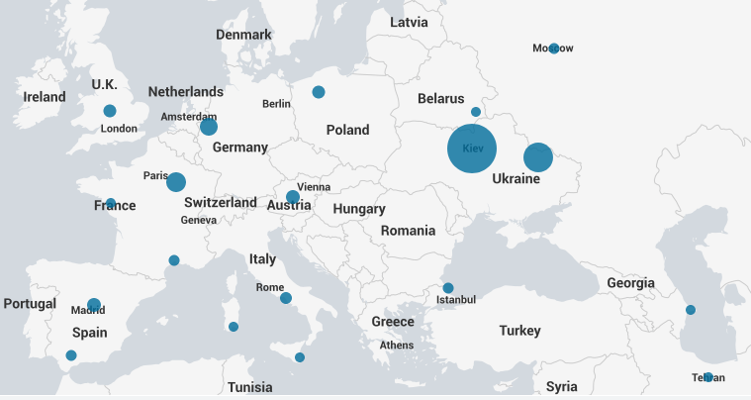
Connections from Kiev rose to 872, which is well above the average and would trip an alert with the set rule

Question 2
- VSI has insider information that JobeCorp will launch the same webserver attack but use a different IP each time in order to avoid being stopped by the rule you just created.
- What other rules can you create to protect VSI from attacks against your webserver?
  - Conceive of two more rules in "plain english".
  - Hint: Look for other fields that indicate the attacker.
    - If POST requests exceed 20 in a 10 minute period of time, send an alert to the SOC
    - If connections to the URI path /VSI_Account_logon.php exceeds 200 in a 5 minute period, send an alert to the SOC

